Facultatea de Automatica si Calculatoare – Automatica si informatica aplicata

***CAD in Automatica***

***Proiect 4***

Student: Costin Denisa- Nicoleta Coordonator: Misaros Marius

Grupa: 30117

***Cuprins:***

1. Descriere proiect …...................................................... pag. 3
2. Printscreen animatie 3D ….....................................................................pag. 3-4

***Descrierea proiectului:***

In cadrul acestui proiect am realizat o animatie 3D in OpenGL, a unei sfere care se roteste de-a lungul axelor Ox, Oy si Oz

***Printscreen cu animatia 3D:***

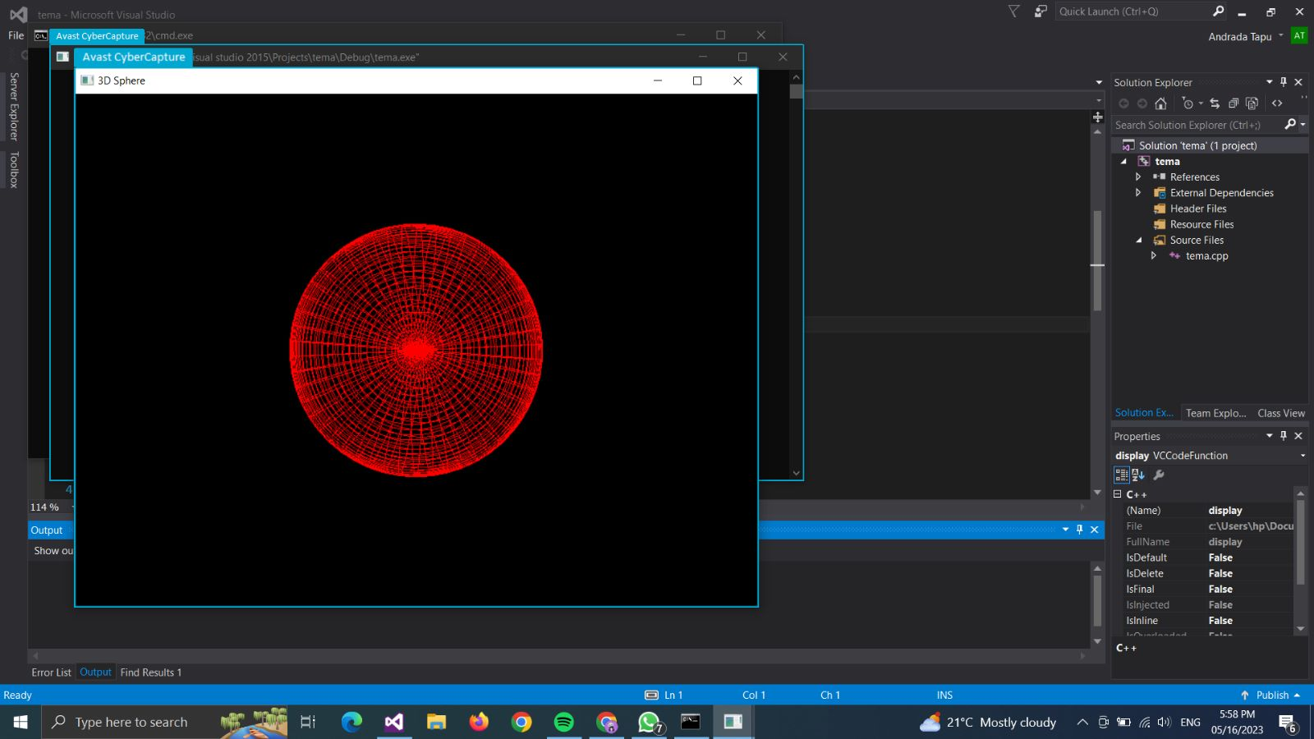

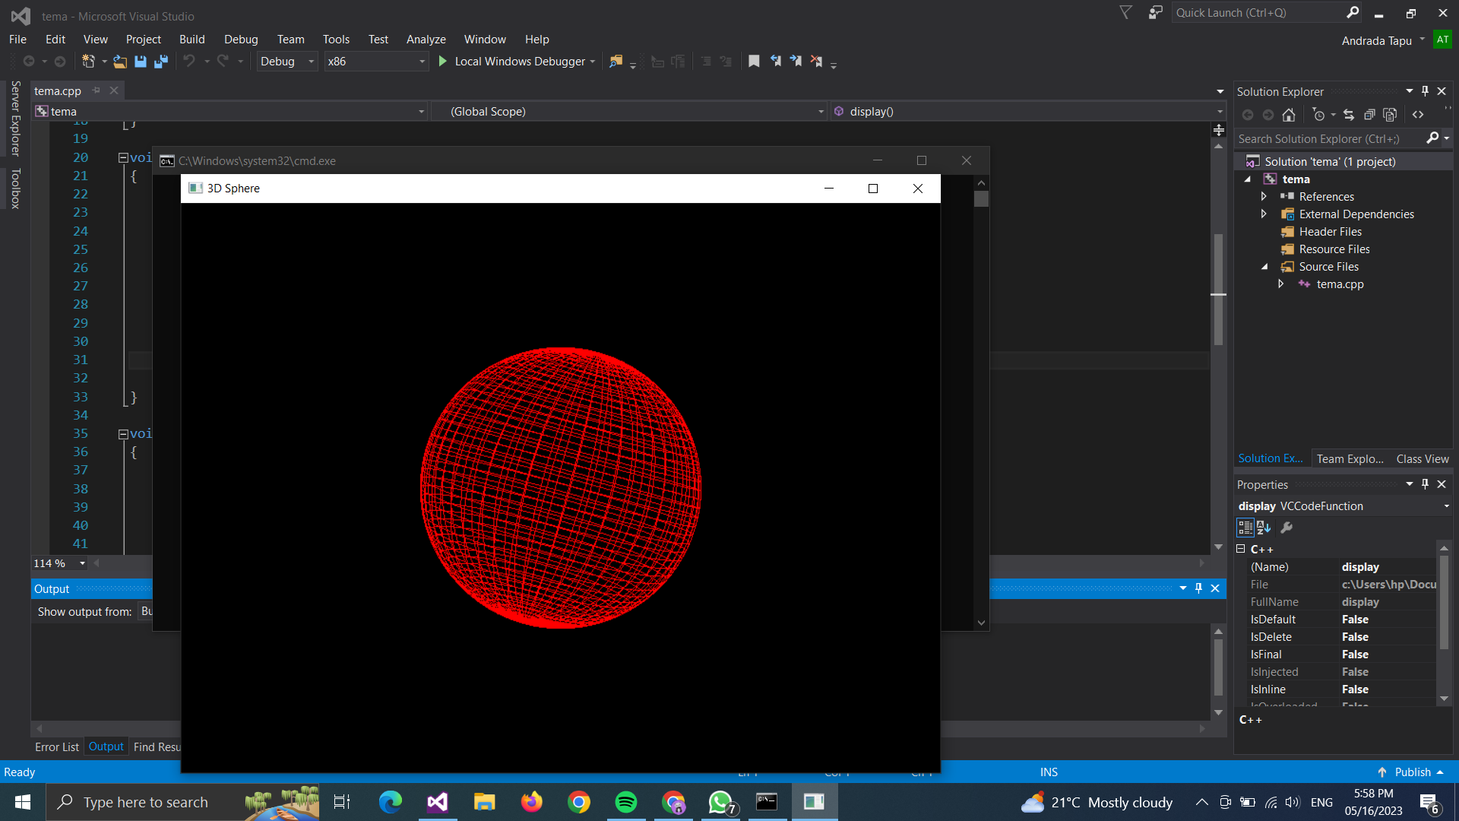

***Codul care realizeaza sfera :***

***#include <Windows.h>***

***#include <GL\glew.h>***

***#include <GL\freeglut.h>***

***#include <iostream>***

***#include <math.h>***

***using namespace std;***

***#include <GL/glut.h>***

***GLfloat spin = 0;***

***void spinDisplay(void)***

***{***

***spin = spin + 2.0;***

***if (spin > 360.0)***

***spin = spin - 360.0;***

***glutPostRedisplay();***

***}***

***void display()***

***{***

***glClear(GL_COLOR_BUFFER_BIT | GL_DEPTH_BUFFER_BIT);***

***glMatrixMode(GL_MODELVIEW);***

***glLoadIdentity();***

***glTranslatef(0.0f, 0.0f, -5.0f);***

***glColor3f(1.0f, 0.0f, 0.0f);***

***glRotatef(spin, 0, 1, 1);***

***glutSolidSphere(1.0f, 50, 50);***

***glPolygonMode(GL_FRONT_AND_BACK, GL_LINE);***

***glutSwapBuffers();***

***}***

***void reshape(int width, int height)***

***{***

***glViewport(0, 0, width, height);***

***glMatrixMode(GL_PROJECTION);***

***glLoadIdentity();***

***gluPerspective(45.0f, (float)width / (float)height, 0.1f, 100.0f);***

***}***

***int main(int argc, char** argv)***

***{***

***glutInit(&argc, argv);***

***glutInitDisplayMode(GLUT_DOUBLE | GLUT_RGB | GLUT_DEPTH);***

***glutInitWindowSize(800, 600);***

***glutCreateWindow("3D Sphere");***

***glEnable(GL_DEPTH_TEST);***

***glutDisplayFunc(display);***

***glutReshapeFunc(reshape);***

***glutIdleFunc(spinDisplay);***

***glutMainLoop();***

***return 0;***

***}***